Super Triangle Bros.

* Controls
  + Left/Right
    - Use the left and right arrows on your keyboard to move about the world
  + Space
    - Use space to jump
  + Z
    - Use z to shoot
* Gameplay
  + You
    - Your objective is to shoot all the squares and collect as many coins as possible. Shooting squares and collecting coins increases your point total. Each time you collect 10 coins, your hp goes up by 10 points as well. Score as many points as possible!
    - Getting shot and touching squares decreases your hp. Falling off results in losing all hp. Reach 0 hp and you lose.
  + Squares
    - The squares are your enemies. They will follow you and shoot at you. Some squares may be more powerful than others, so be careful.
  + Coins
    - Coins are scattered about the world. Collect for health and scoring bonuses.
    - Mega coins are very rare but give you a great boost in health and points.
  + Platforms
    - Aside from the ground, there are floating and moving platforms. Try not to fall off!
  + Display
    - 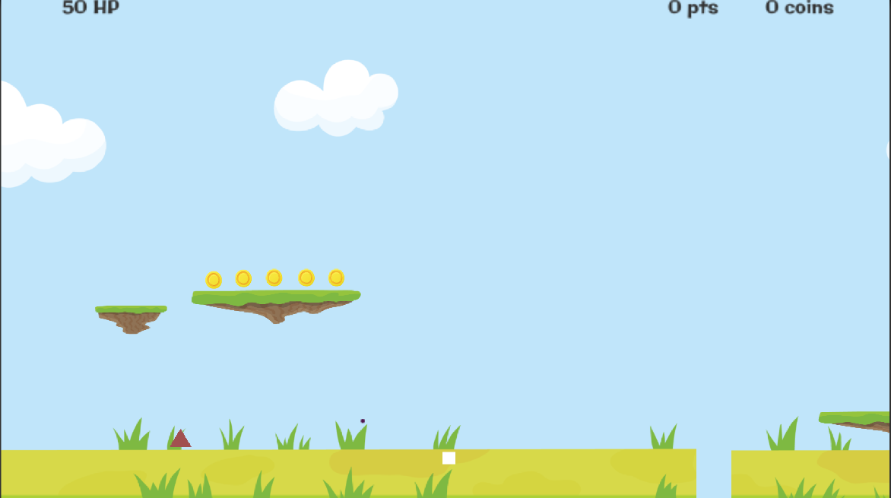IF YOU CAN’T SEE THE HUD (HP, PTS, COINS), try changing the zoom in the game display settings.